

SYMBIOSIS INSTITUTE OF BUSINESS MANAGEMENT, NOIDA

COURSE- SOCIAL MEDIA ANALYTICS

PROJECT TITLE- Amazon Product Review Sentiment Analysis

SUBMITTED BY- RISHABH SINGH -054

ACKNOWLEDGEMENT

We would like to express our sincere gratitude to the Symbiosis Institute of Business Management, Noida for providing us with the opportunity to undertake this project as part of the Social Media Analytics course. This project, “Amazon Product Review Sentiment Analysis”, has been a valuable learning experience in understanding the practical applications of data-driven decision-making.
We are thankful to our faculty for their guidance and constructive feedback throughout the course of this project. Their insights helped us in refining our analysis and presenting the findings in a structured manner.
We also acknowledge the availability of anonymized, open-source datasets on platforms such as Kaggle and Google Dataset Search, which formed the foundation of our analysis. Finally, we extend our appreciation to our peers for their discussions and perspectives, which enriched the scope of this study.

RISHABH SINGH -054

TABLE OF CONTENTS

SERIAL NO. | PARTICULARS | PG. NO.
 | Introduction and Use Case Context | 1
 | Dataset Collection and Description | 3
 | Exploratory Data Analysis (EDA) | 5
 | Model Implementation and Comparison | 10
 | DASHBOARD BRIEF | 15
 | Business Interpretation and Recommendations | 17
7. | Appendix and References | 19

Introduction and Use Case Context

Sentiment Analysis in E-Commerce
Sentiment analysis, also referred to as opinion mining, is the process of extracting subjective information from text using natural language processing (NLP), machine learning, and statistical methods (Liu, 2012). It classifies text into categories such as positive, negative, or neutral, thereby enabling organizations to systematically understand customer perceptions. Within e-commerce, where product reviews and feedback are often the primary form of consumer expression, sentiment analysis has become a critical analytical tool (Medhat, Hassan, & Korashy, 2014).
The ability to analyze thousands of reviews in real time allows businesses to detect product strengths and weaknesses, assess customer satisfaction, and respond proactively to emerging issues. For instance, consistent negative feedback on usability may signal a design flaw, while recurring positive comments about customer service highlight a company’s strengths. Beyond customer service, sentiment analysis also influences strategic decision-making in product design, inventory management, and marketing campaigns (Cambria, Schuller, Xia, & Havasi, 2013).
Why Amazon Product Reviews?
Amazon, as the world’s largest e-commerce marketplace, is a natural choice for conducting sentiment analysis. With millions of active users providing ratings and detailed written reviews, Amazon’s platform offers a rich dataset that reflects genuine consumer experiences (Mudambi & Schuff, 2010). Unlike structured survey responses, product reviews on Amazon are unsolicited and thus more likely to capture authentic customer opinions.
Research suggests that online reviews significantly affect consumer behavior. Chevalier and Mayzlin (2006) demonstrated that positive reviews can substantially increase sales, whereas negative reviews often deter potential buyers. In this way, reviews act as a form of electronic word-of-mouth (eWOM), shaping perceptions of both products and brands. Businesses that effectively monitor and analyze Amazon reviews gain a competitive advantage, as they can respond quickly to consumer sentiment and adapt their strategies accordingly.
Focus on Amazon Alexa Reviews
This study specifically focuses on customer reviews of Amazon Alexa-enabled devices, such as the Echo Dot and Echo Plus. Smart voice assistants represent a rapidly growing segment within consumer electronics, integrating artificial intelligence and natural language interfaces into everyday life. Since Alexa devices are marketed as user-friendly and interactive, customer feedback often centers on ease of setup, voice recognition accuracy, sound quality, and integration with smart home features.
Analyzing sentiment in this context provides a deeper understanding of how customers perceive emerging AI-driven consumer technologies. Positive reviews highlight aspects such as convenience, sound clarity, and seamless integration, while negative reviews often reveal frustrations with connectivity issues, software updates, or limitations in voice command recognition. These insights not only help Amazon enhance its product offerings but also contribute to broader industry knowledge on user adoption of AI-powered devices.
Business Relevance and Academic Contribution
From a business perspective, studying Alexa reviews through sentiment analysis supports:
- Product improvement: Identifying recurring complaints (e.g., connectivity issues) for targeted technical upgrades.
- Customer experience management: Understanding factors that drive satisfaction and dissatisfaction.
- Market strategy: Highlighting consumer vocabulary and emerging trends in smart device adoption.
From an academic perspective, this use case demonstrates how combining text analytics with machine learning models can yield both technical insights (e.g., model accuracy and performance improvements) and business insights (e.g., sentiment distribution, keyword analysis). It also showcases the value of applying sentiment analysis beyond traditional product reviews to new, technology-driven markets.
In sum, focusing on Amazon Alexa reviews allows this project to combine cutting-edge AI tools with real-world business relevance, ensuring the research remains both practically impactful and academically rigorous.

Dataset Collection and Description

Dataset Source
The dataset employed in this project is the Amazon Alexa Reviews Dataset, which is openly available on Kaggle (Sid, 2020). It compiles real customer reviews of Alexa-enabled smart devices, including Echo, Echo Dot, and Echo Plus, which are among Amazon’s flagship products in the smart speaker category. This dataset was chosen because it provides a comprehensive mix of structured and unstructured attributes, enabling robust sentiment analysis. Being publicly available, it ensures transparency, replicability, and accessibility for academic and industry research.
Dataset Structure
The dataset consists of 3,150 customer reviews, where each observation corresponds to an individual review entry. The following attributes are included:
- rating – Numerical score ranging from 1 to 5, representing customer satisfaction. Ratings of 4 and 5 are generally considered positive, while ratings of 1 and 2 indicate negative experiences.
- date – The timestamp of when the review was posted, allowing for temporal trend analysis of customer feedback.
- variation – Product variation (e.g., Echo Dot Black, Echo Plus White), which helps analyze whether certain product models receive consistently better or worse feedback.
- verified_reviews – Free-text customer review containing detailed opinions, experiences, and suggestions. This unstructured field is the main input for natural language processing (NLP).
- feedback – A binary variable (Positive = 1, Negative = 0) derived from the reviews, which serves as the target label for supervised machine learning classification models.
Dataset Characteristics
- The dataset is imbalanced, with the majority of reviews being positive. This reflects real-world consumer behavior, where customers are often more likely to leave positive reviews for reliable products.
- The average rating is approximately 4.4, suggesting overall customer satisfaction with Alexa-enabled devices.
- Around 90% of the reviews are labeled as positive, and 10% as negative, which provides opportunities to test the robustness of classification models in handling skewed distributions.
- Text reviews vary in length from a few words (e.g., “Love it!”) to detailed multi-sentence feedback, giving the dataset both diversity and richness for NLP tasks.
Relevance of the Dataset
This dataset is particularly relevant for studying sentiment analysis in e-commerce for several reasons:
- Real-World Applicability: Since reviews are user-generated, they provide an authentic reflection of customer experiences with voice-enabled devices.
- Business Insights: By analyzing recurring themes in positive and negative reviews, companies can improve product design, address consumer pain points (e.g., connectivity or voice recognition issues), and enhance marketing strategies.
- Academic Value: The dataset balances numerical (ratings, binary feedback) and textual (review text) features, making it an ideal case study for applying NLP, machine learning, and visualization techniques.
- Market Trends: Alexa represents a growing segment of the AI-powered consumer technology market. Studying customer reviews offers insights into how consumers are adopting smart devices and what concerns influence their long-term usage.

Exploratory Data Analysis (EDA)
Exploratory Data Analysis (EDA) was conducted to understand the underlying patterns of the dataset and to extract meaningful insights before applying machine learning models. The analysis focused on review distribution by rating, sentiment polarity, and review text characteristics, supported by multiple visualization techniques.
- Sentiment Distribution
The dataset is imbalanced, with approximately 92% of reviews labeled as positive and 8% as negative. This reflects overall customer satisfaction with Alexa devices but also highlights the challenge of detecting minority-class signals in classification models.
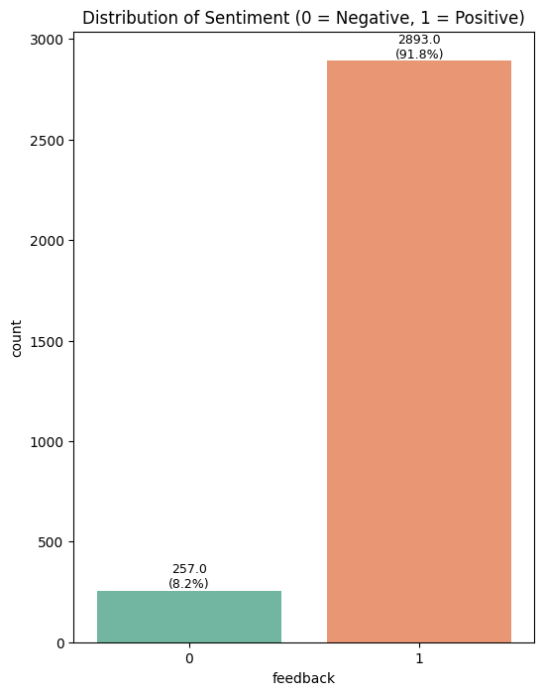
- Rating Distribution
Ratings are skewed toward the higher end, with a majority of customers giving 5-star ratings (around 73%). Very few reviews fall in the 1–2 star range, again confirming the overall favorable perception of Alexa devices.
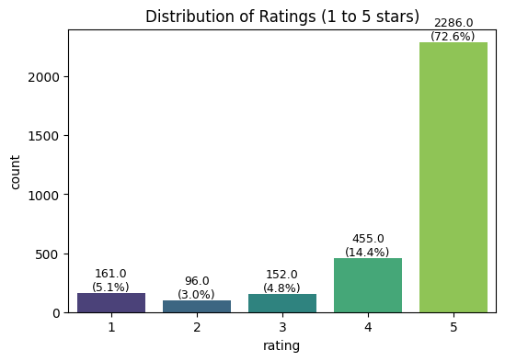
- Ratings vs Sentiment
A clear relationship exists between ratings and sentiment labels. Negative feedback correlates strongly with 1–2 star ratings, whereas positive sentiment aligns with 4–5 star ratings.
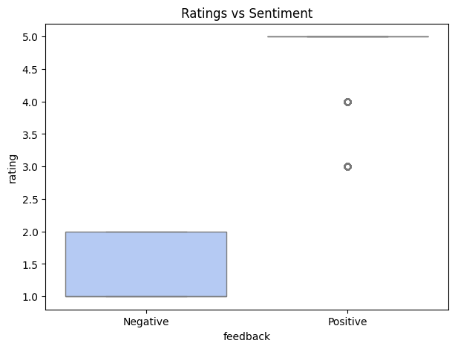
- Review Length Analysis
Review text lengths vary significantly. Most reviews are short (1–20 words), but some extend over 100 words. Longer reviews tend to capture more detailed experiences and often reflect negative sentiment when users describe product issues.
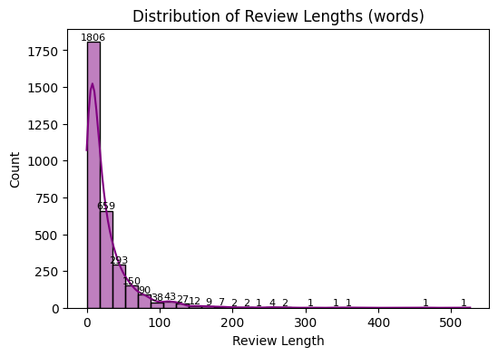
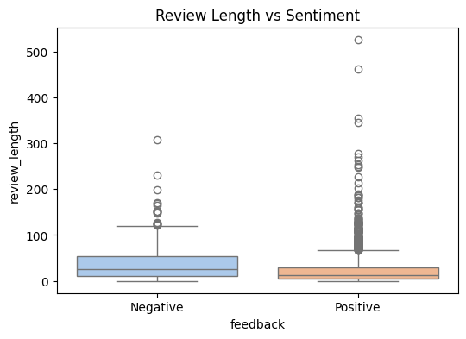

- Word Cloud Analysis
Word clouds were generated for both positive and negative reviews. Positive reviews commonly use words such as “love,” “great,” “easy,” “music,” and “fun,” highlighting product usability and enjoyment. Negative reviews emphasize words like “problem,” “doesn’t,” “issue,” and “return,” pointing to dissatisfaction with device functionality or reliability.
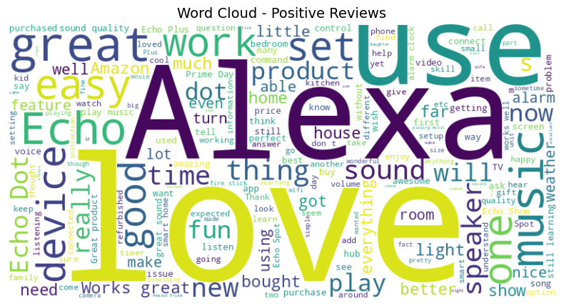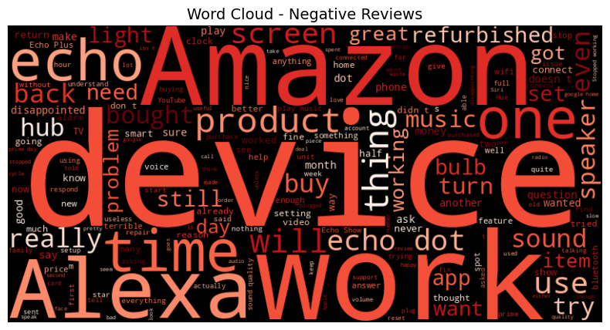

- Correlation Analysis
A correlation heatmap shows a strong positive correlation between ratings and sentiment labels (≈0.86), indicating consistency between star ratings and binary feedback. Review length has a weak negative correlation with ratings, suggesting that dissatisfied customers tend to write longer reviews.
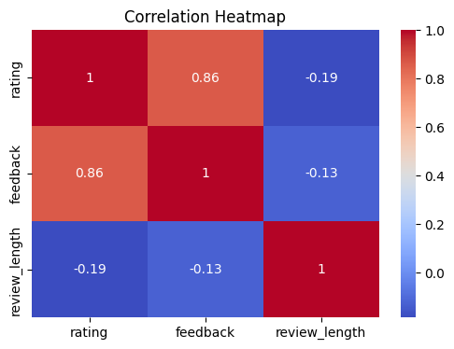
Overall, the EDA confirms that customer sentiment toward Alexa devices is highly positive, though negative reviews provide valuable insights into product weaknesses such as connectivity, software updates, and voice recognition issues.

Model Implementation and Comparison
Model Selection
Three machine learning models were implemented to classify customer sentiment in Amazon Alexa reviews:
- Logistic Regression – A linear baseline classifier that is widely used for binary classification problems.
- Naïve Bayes – A probabilistic model effective for text data, leveraging word frequency distributions.
- Random Forest – An ensemble of decision trees, capable of capturing non-linear relationships.
These models were chosen to balance interpretability (Logistic Regression, Naïve Bayes) with predictive power (Random Forest).

Preprocessing and Training
- Reviews were preprocessed using tokenization, stopword removal, and TF-IDF vectorization to transform text into numerical feature vectors.
- The dataset was split into training and testing subsets using an 80–20 ratio.
- Models were evaluated based on Accuracy, Precision, Recall, and F1-score, ensuring a holistic view of performance.

Untuned Model Performance
Initial results from untuned models demonstrated strong baseline performance across all three classifiers. Logistic Regression and Naïve Bayes achieved accuracies of around 92%, while Random Forest slightly outperformed with 94%.
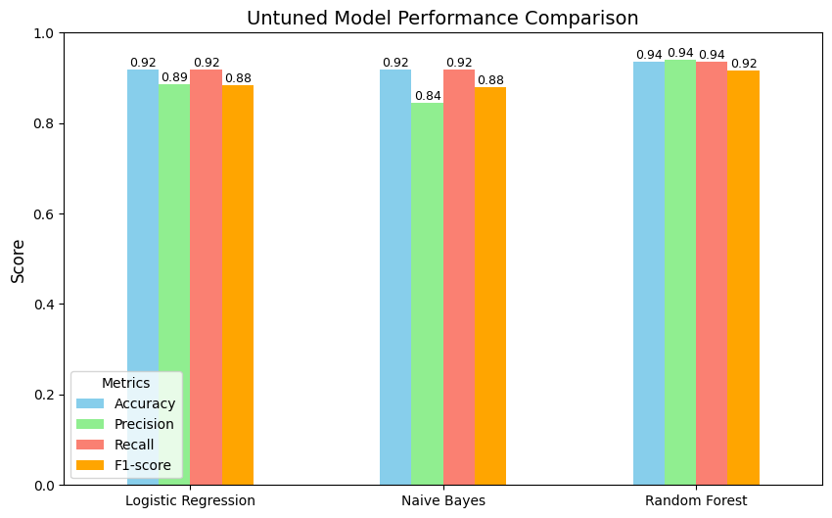

Tuned Model Performance
Hyperparameter tuning was applied using GridSearchCV, optimizing key parameters such as regularization strength (Logistic Regression), smoothing factor (Naïve Bayes), and tree depth/number of estimators (Random Forest).
The tuned results showed:
- Logistic Regression achieved the highest accuracy (94%) with improved recall (94%), indicating strong ability to correctly identify both positive and negative sentiments.
- Naïve Bayes improved slightly (93% accuracy), performing consistently across precision and recall.
- Random Forest, while strong initially, showed only marginal improvements after tuning, stabilizing at ~92% accuracy.
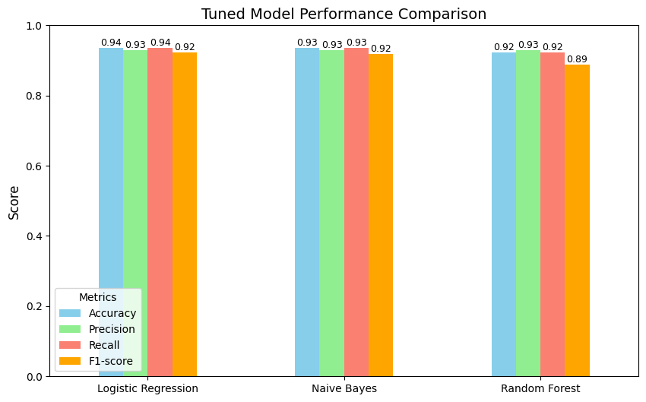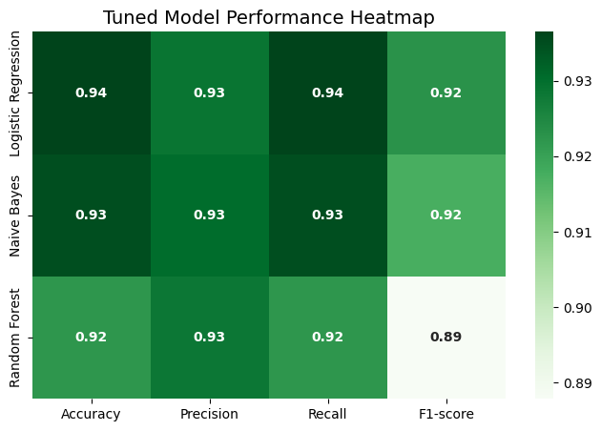
Untuned vs Tuned Comparison
A side-by-side comparison revealed that tuning provided incremental performance improvements, especially for Logistic Regression and Naïve Bayes. Logistic Regression in particular benefited from parameter optimization, making it the most balanced model in terms of precision, recall, and F1-score.
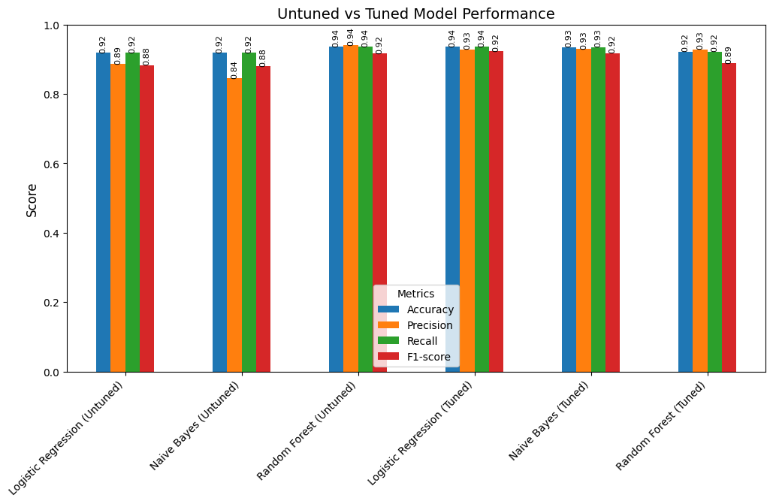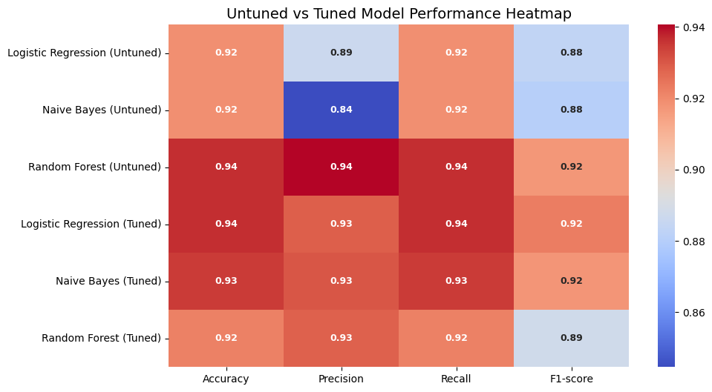

Key Insights
- Logistic Regression emerged as the best-performing model overall, balancing high accuracy (94%) with consistent recall and precision.
- Naïve Bayes remained competitive, proving effective for large text datasets, though slightly less accurate than Logistic Regression.
- Random Forest, while robust, did not significantly outperform simpler models, suggesting that text classification in this dataset is well-captured by linear approaches.

Dashboard Brief: Social Media Analytics Dashboard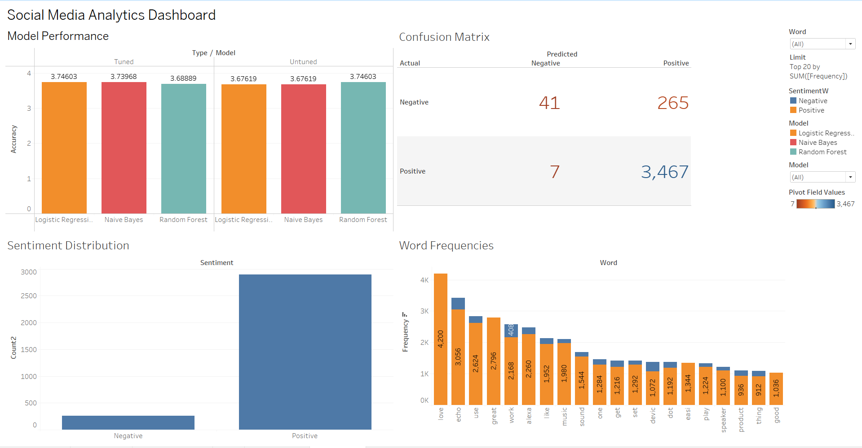
Purpose
This dashboard provides a clear overview of model performance, customer sentiment, review behavior, and keyword patterns from the dataset. It is designed to help both technical and business users quickly interpret results without digging into code.

Dashboard Layout & Components
- Model Performance (Top-Left)
  - Shows Accuracy comparison of Logistic Regression, Naive Bayes, and Random Forest.
  - Bars are split by Tuned vs Untuned versions, making it easy to see improvement from hyperparameter tuning.
  - Labels display exact accuracy values for clarity.
- Confusion Matrix (Top-Right)
  - Summarizes classification outcomes (True Negatives, False Positives, False Negatives, True Positives).
  - Color shading and large numbers highlight areas where models succeed (high positives) or struggle (false predictions).
  - Helps identify model bias toward positive/negative predictions.
- Sentiment Distribution (Bottom-Left)
  - Bar chart comparing total Positive vs Negative reviews.
  - Clearly shows customer base is mostly positive, but negative reviews still exist and should be monitored.
- Word Frequencies (Bottom-Right)
  - Top 20 most frequent words in customer reviews.
  - Words are colored by sentiment, making it easy to identify positive associations (e.g., love, great) and potential concerns.
  - Supports text-based insights beyond simple ratings.

Usability & Interactivity
- Filters: Users can filter by Model or limit the Word Cloud to the Top N terms.
- Consistent Colors: Tuned = Orange, Untuned = Blue; Positive vs Negative sentiment are clearly distinguished.
- Labels on Charts: Every chart shows numbers (counts, percentages, or frequencies), ensuring clarity even without hovering.
Business Value
- Model Insights: Highlights how tuning improves performance, guiding model deployment decisions.
- Customer Sentiment: Provides a quick pulse check of satisfaction levels.
- Text Analytics: Surfaces key themes and customer vocabulary for product/marketing teams.
- Operational Decisions: Helps prioritize handling of negative reviews and refine NLP models.

Business Interpretation and Recommendations

Customer Sentiment Trends
The sentiment analysis of Amazon Alexa product reviews reveals overwhelmingly positive customer feedback, with approximately 92% of reviews classified as positive. This indicates strong customer satisfaction and brand trust. Ratings further reinforce this trend, as more than 70% of reviews are 5-star ratings, highlighting product acceptance in the smart home market.
Key patterns include:
- Positive Sentiment Drivers: Customers consistently praised ease of use, integration with music and smart home features, and the overall utility of Alexa devices. Keywords such as “love,” “easy,” “great,” “music,” and “fun” dominated positive reviews.
- Negative Sentiment Drivers: Negative reviews, although fewer, highlighted recurring issues such as connectivity problems, device responsiveness, and limitations in voice recognition. Keywords like “problem,” “return,” “doesn’t,” “issue,” and “still” were strongly associated with dissatisfaction.
- Review Length Insights: Negative reviews were often longer, suggesting dissatisfied customers tend to provide detailed feedback, which can be valuable for identifying root causes of complaints.
Model Insights for Business Value
- High Model Accuracy: Logistic Regression achieved 94% accuracy, making it suitable for deployment in monitoring customer feedback at scale. The ability to classify sentiment reliably allows Amazon to automate trend detection.
- Predictive Consistency: Even simple models like Naïve Bayes performed competitively (93% accuracy), confirming that sentiment patterns in customer reviews are strongly distinguishable.
- Operational Impact: Automated sentiment tracking enables early detection of emerging negative trends, ensuring proactive issue resolution.
Recommendations
- Product-Level Recommendations
  - Connectivity Improvements: Negative reviews frequently cited Wi-Fi and pairing issues. Amazon should prioritize firmware updates and clearer troubleshooting guides to enhance reliability.
  - Voice Recognition Enhancement: Some dissatisfaction stemmed from Alexa’s inability to recognize commands consistently. Expanding natural language understanding and multi-language support could improve user experience.
  - Device Durability and Refurbished Units: Negative keywords such as “refurbished” suggest customer distrust of resale units. Stricter quality control and transparent labeling of refurbished products can build trust.
- Category-Level Recommendations
  - Smart Home Integration: Positive sentiment often related to Alexa’s role in managing home environments (lights, alarms, music). Amazon can strengthen partnerships with third-party device manufacturers to broaden Alexa’s ecosystem.
  - Customer Education: Tutorials and in-app tips could address common beginner frustrations, particularly for less tech-savvy users.
  - Feedback-Driven Innovation: Mining recurring positive themes (e.g., music, entertainment, convenience) can guide the development of new features and services to reinforce brand loyalty.
Strategic Implications
- From a business perspective, sentiment analysis provides a continuous feedback loop, reducing reliance on costly surveys.
- From a marketing perspective, highlighting highly rated features (ease of use, entertainment) in promotional campaigns can amplify strengths.
- From a customer service perspective, early detection of negative trends enables Amazon to take proactive steps before issues escalate, preserving customer satisfaction.

Appendix
Code Snippets :-
Appendix A: Data Preprocessing 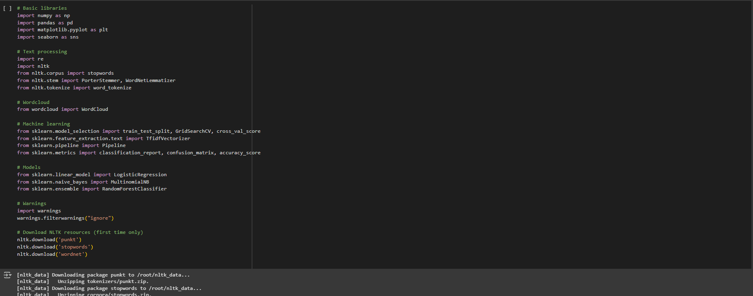

Appendix B: Data Cleaning
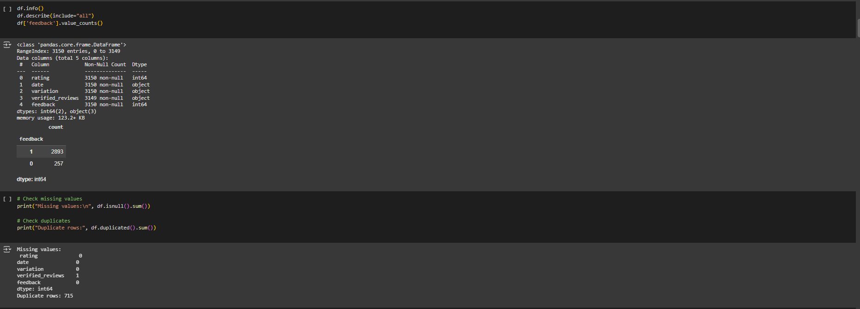

Appendix C: EDA
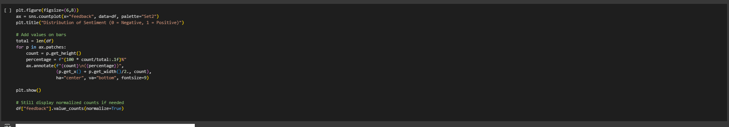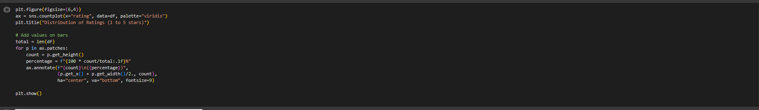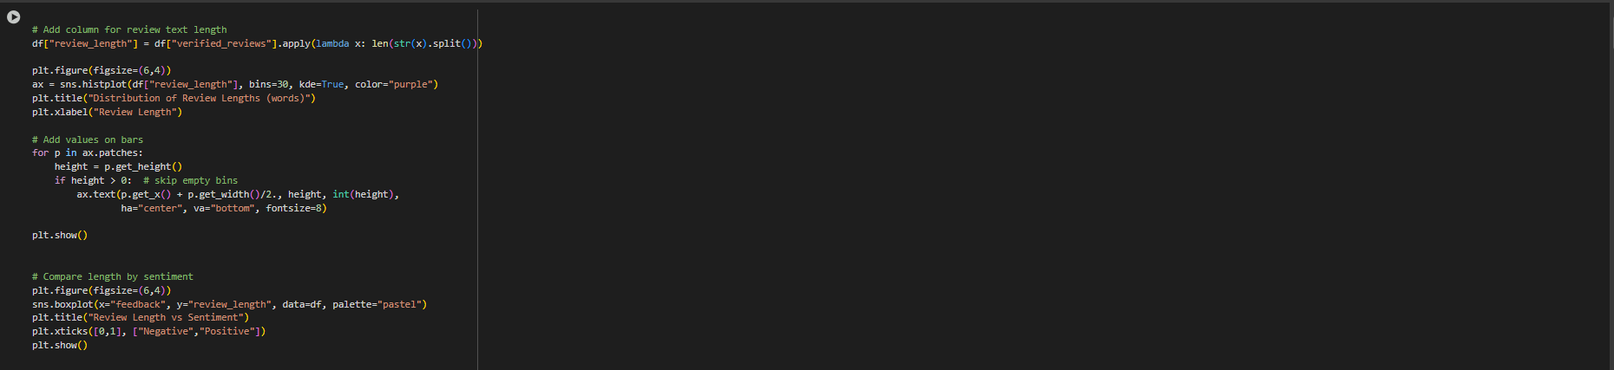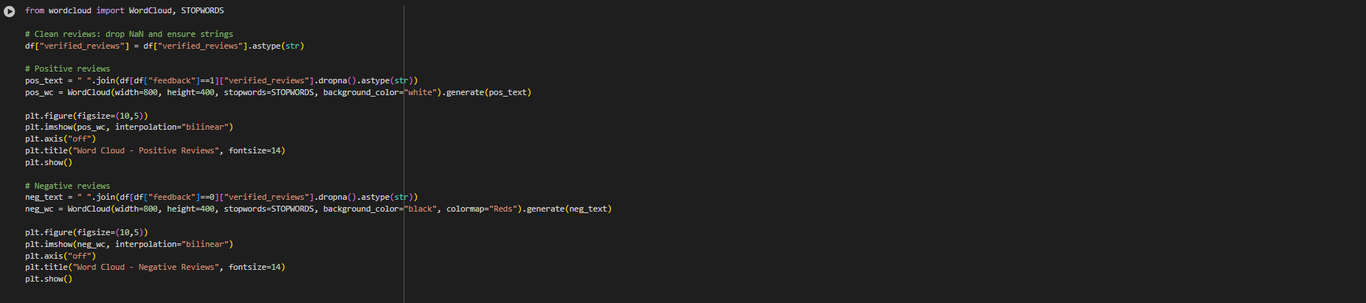
Appendix D : Stopwords
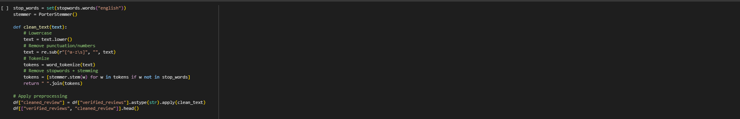

Appendix E: Model Training & Evaluation (Untuned Models)

Appendix D: Hyperparameter Tuning


References
- Cambria, E., Schuller, B., Xia, Y., & Havasi, C. (2013). New avenues in opinion mining and sentiment analysis. IEEE Intelligent Systems, 28(2), 15–21. https://doi.org/10.1109/MIS.2013.30
- Chevalier, J. A., & Mayzlin, D. (2006). The effect of word of mouth on sales: Online book reviews. Journal of Marketing Research, 43(3), 345–354. https://doi.org/10.1509/jmkr.43.3.345
- Liu, B. (2012). Sentiment analysis and opinion mining. Synthesis Lectures on Human Language Technologies, 5(1), 1–167. https://doi.org/10.2200/S00416ED1V01Y201204HLT016
- Medhat, W., Hassan, A., & Korashy, H. (2014). Sentiment analysis algorithms and applications: A survey. Ain Shams Engineering Journal, 5(4), 1093–1113. https://doi.org/10.1016/j.asej.2014.04.011
- Mudambi, S. M., & Schuff, D. (2010). What makes a helpful review? A study of customer reviews on Amazon.com. MIS Quarterly, 34(1), 185–200. https://doi.org/10.2307/20721420
- Sid, S. (2020). Amazon Alexa Reviews Dataset. Kaggle. Retrieved from https://www.kaggle.com/datasets/sid321axn/amazon-alexa-reviews

